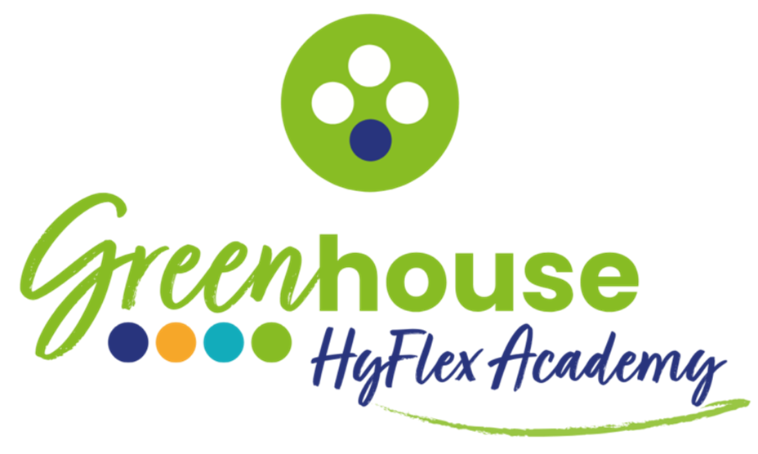

Telford Court

SEND Policy
2026-2027

Contents
1. Policy Statement
2. Legal Framework
3. Roles and Responsibilities
4. Identification of SEND
5. EHCP and IDP Implementation and Review
6. Provision and Support
7. Personal Education Plans (PEPs)
8. Equality and Inclusion
9. Monitoring and Review
10. Related Policies
1. Policy Statement
The Greenhouse HyFlex Academy is committed to meeting the needs of all young people aged 11 to 19 with special educational needs and disabilities (SEND). The Greenhouse's provision is, by its nature, needs-led and highly individualised. Every young person who attends The Greenhouse has a bespoke learning plan that reflects their strengths, needs, aspirations and any identified SEND.
The Greenhouse is a non-school alternative provision setting. All of the young people who attend have Education, Health and Care Plans (EHCPs) or Individual Development Plans (IDPs). SEND is not an add-on at The Greenhouse — it is central to how the provision operates.
This policy aligns with the DfE Non-School Alternative Provision Voluntary National Standards (August 2025) and the SEND Code of Practice: 0 to 25 years (2015, updated 2020).

2. Legal Framework
This policy has regard to:
- Children and Families Act 2014
- SEND Code of Practice: 0 to 25 years (2015, updated 2020)
- Equality Act 2010
- Education Act 1996
- DfE Non-School Alternative Provision Voluntary National Standards (August 2025)
- Keeping Children Safe in Education (KCSIE) 2026
- Care Act 2014
- Additional Learning Needs and Education Tribunal (Wales) Act 2018

3. Roles and Responsibilities
Headteacher
The Headteacher holds overall accountability for SEND provision and ensures that this policy is implemented consistently across The Greenhouse.
SENCO
The SENCO is responsible for:
- Overseeing the identification, assessment and support of all young people with SEND
- Ensuring all EHCPs and IDPs are implemented and reviewed in line with statutory timescales
- Liaising with commissioning Local Authorities, virtual school heads, social workers and other professionals
- Supporting staff to adapt teaching and provision to meet individual SEND needs
- Maintaining accurate SEND records for each young person
All Teaching Staff
All teaching staff are responsible for delivering high-quality, differentiated teaching that meets the needs of every young person. Staff work closely with the SENCO to understand and respond to individual SEND requirements.

4. Identification of SEND
Young people arrive at The Greenhouse having already been identified as having needs that cannot be met in a mainstream or specialist school setting. On admission, the Headteacher and SENCO will:
- Review all available documentation, including EHCPs, IDPs, previous assessments, school records and care plans
- Meet with the young person and, where appropriate, their carer or social worker
- Conduct or commission any additional assessments required to understand the young person's needs
- Develop or contribute to the young person's bespoke learning plan
Where a need is identified during a young person's time at The Greenhouse that was not previously recognised, the SENCO will initiate appropriate assessment and notify the commissioning Local Authority.

5. EHCP and IDP Implementation and Review
Where a young person has an Education, Health and Care Plan (EHCP) or an Individual Development Plan (IDP), The Greenhouse is responsible for implementing the educational outcomes set out in the plan. The SENCO will:
- Ensure all EHCP or IDP outcomes are incorporated into the young person's bespoke learning plan
- Report on progress against EHCP or IDP outcomes as part of any statutory annual review
- Attend or contribute to annual review meetings as requested by the commissioning Local Authority
- Notify the Local Authority immediately of any significant change in the young person's needs or circumstances

6. Provision and Support
The Greenhouse provides a range of SEND support through its flexible, needs-led model, including:
- Bespoke learning plans with individual timetables and learning hours adapted to the young person's capacity
- Trauma-informed, relational approaches embedded across all provision
- Adaptive teaching that responds to sensory, cognitive, emotional and communication needs
- Access to therapeutic and wellbeing support as appropriate
- Transition and intervention support provided by the Transition and Intervention Practitioner
- Access to specialist assessments and external professionals as required

7. Personal Education Plans (PEPs)
All looked-after young people at The Greenhouse have a Personal Education Plan (PEP) maintained by their Virtual School Head. These meetings are led by the Headteacher, however all education staff contribute to PEP reviews and ensure that educational targets within the PEP are aligned with The Greenhouse's provision. PEP meetings are treated with the same priority as annual EHCP reviews.

8. Equality and Inclusion
The Greenhouse is committed to making reasonable adjustments to ensure all young people with SEND can access education on an equal basis. No young person will be disadvantaged due to a disability or special educational need. The Greenhouse actively considers the needs of young people with SEND in all aspects of its operation, including physical access, communication, curriculum design and assessment.

9. Monitoring and Review
SEND provision is reviewed as part of each young person's termly progress review. This policy is reviewed annually by the Headteacher and SENCO and approved by the Business Director.

10. Related Policies
This policy must be read in conjunction with the following related policies:
- Admissions, Onboarding and Referral Policy
- Attendance Policy
- Curriculum Policy
- Assessment Policy
- Safeguarding and Child Protection Policy
- Learner Welfare Policy

This policy has been written by Fiona Conde (Headteacher) and approved by Jonathon Simpson (Business Director).
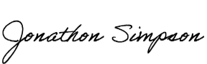
Approval Date: June 2026
Review Date: June 2027

